Answer 1)

// The sheep enters the corn meadow

Set Ear Value= 0

Take Ear1Value From User=

IF (Ear 1 Value>Ear Value)

Print F(“The sheep will pick the Corn”)

Take Ear 2 Value From User=

IF (Ear 2 Value>Ear 1 Value)

Printf (“The sheep dropped the small ear and picked up the bigger ear”)

ELSE

Printf (“The sheep explores the meadow to find a bigger ear”)

Take Ear 3 Value From User=

IF (Ear3Value>=3)

Printf(“The sheep drops the smaller corn and picks up a bigger ear”)

// line break

Printf(“The sheep leaves the meadow after picking up the biggest corn”)

ELSE

Printf(“The sheep continues to explore the meadow to find the biggest corn”)

Continue To Input Value Of Ear 3 Till Ear 3 Value >=

Answer 2)

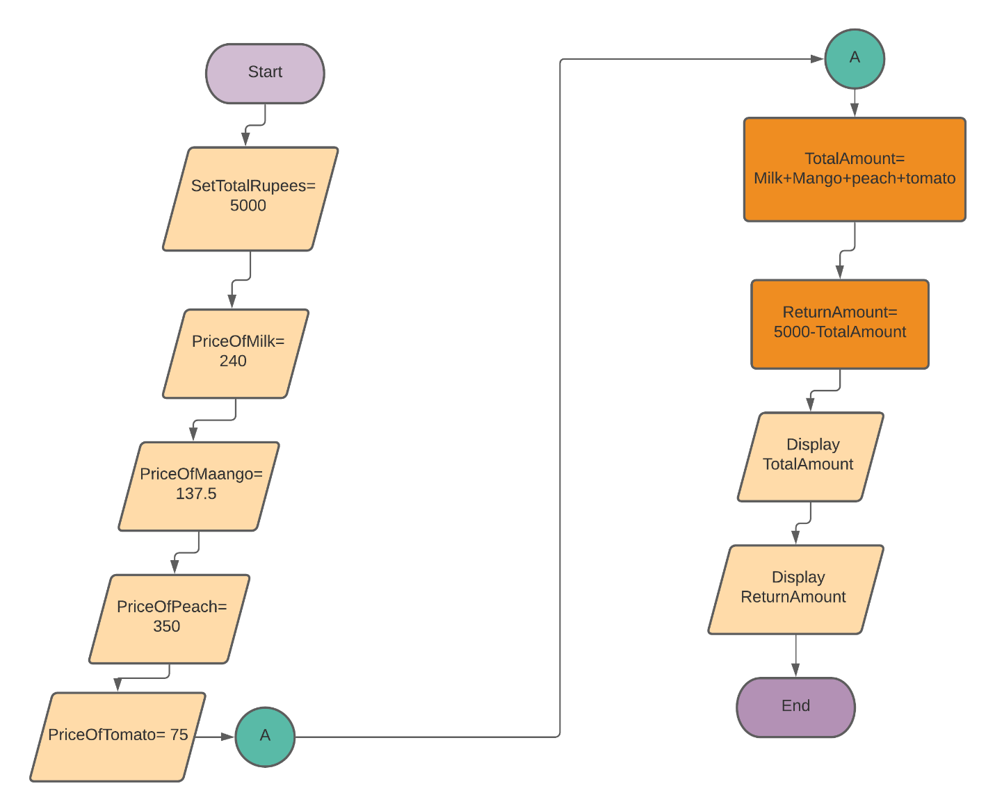

Answer 3)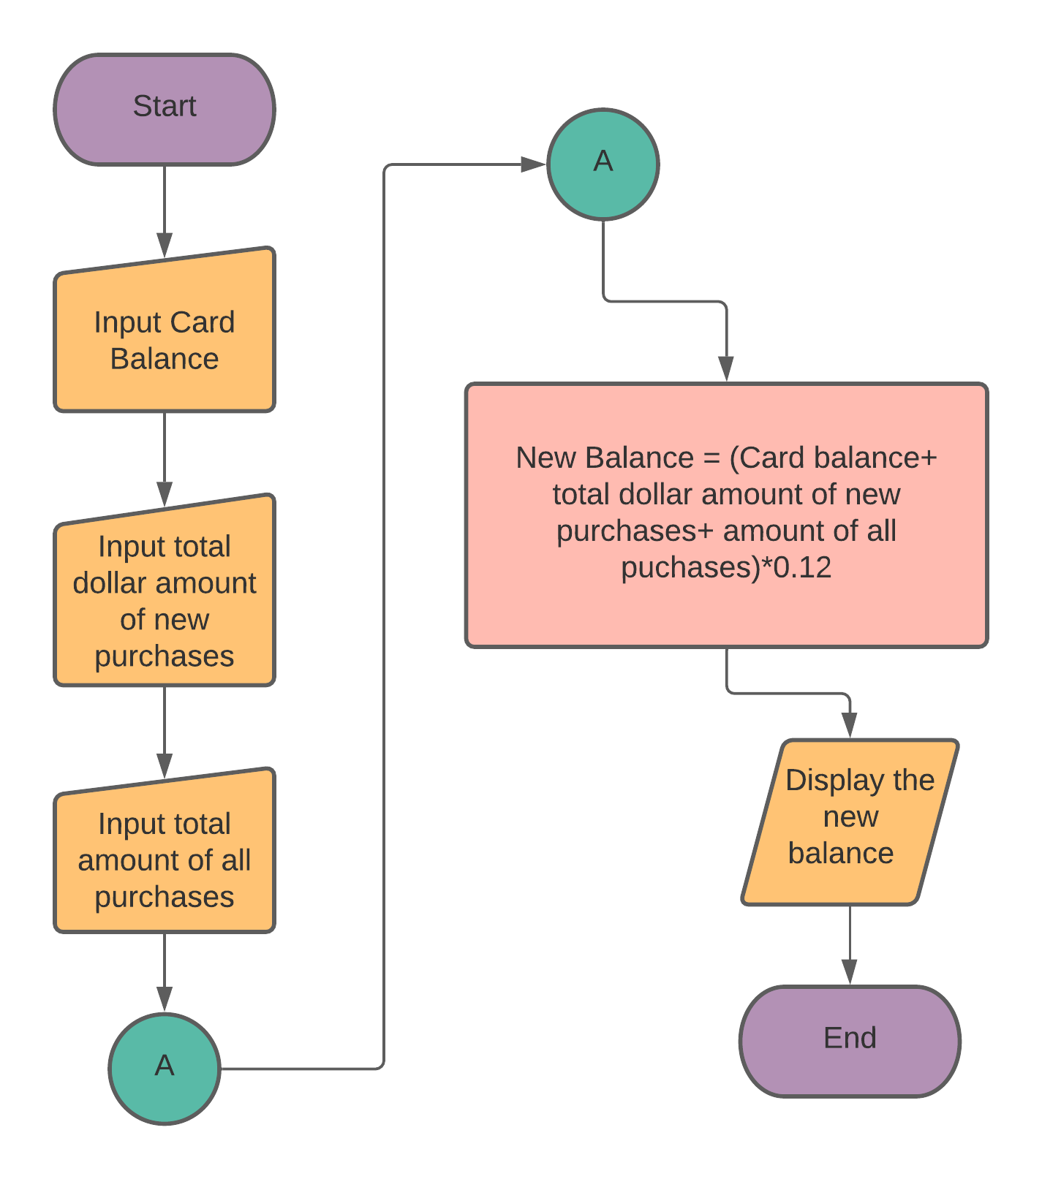

Answer 4)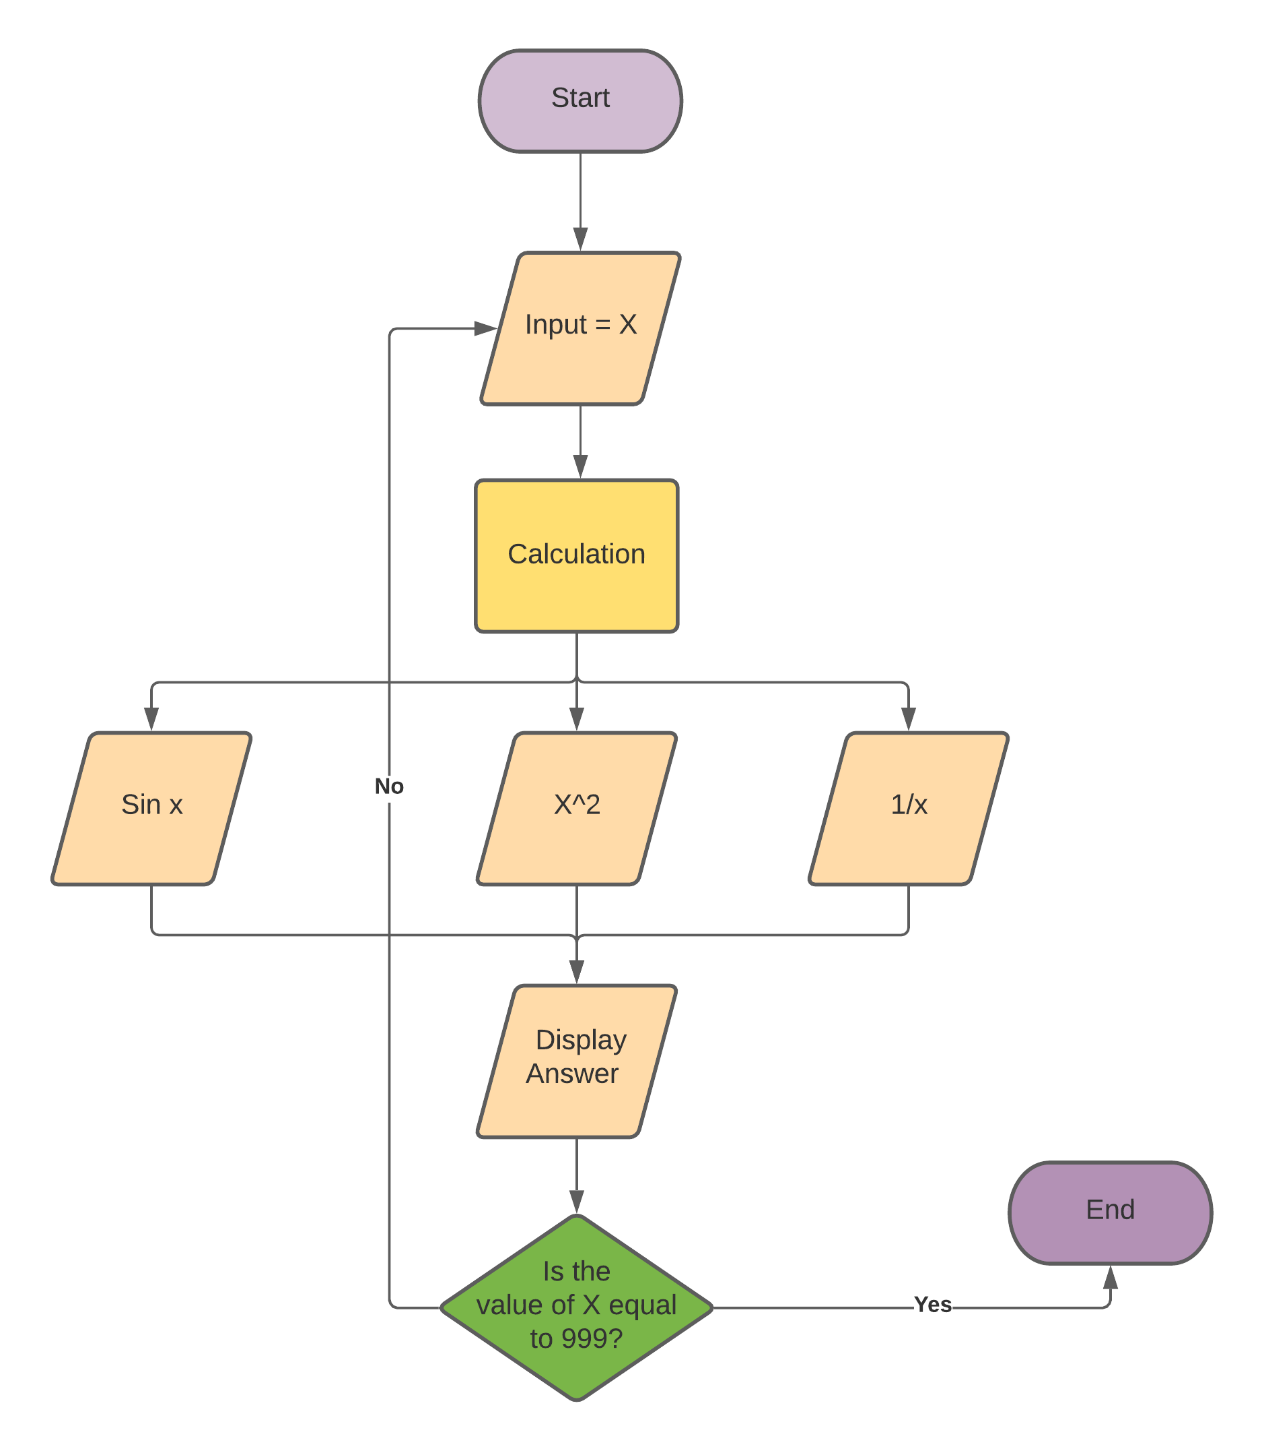

Answer 5)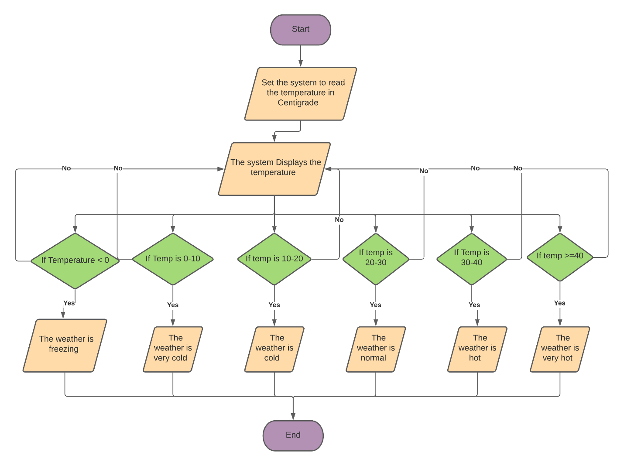

Answer 6)

**Flowchart:**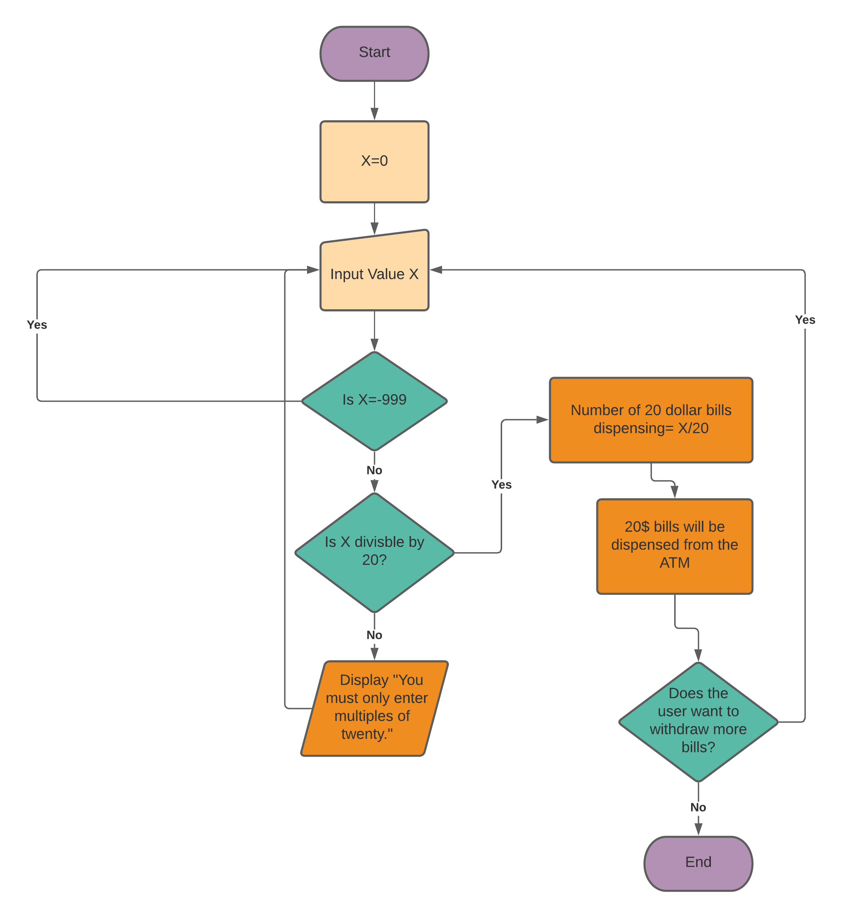

**Program Analysis Chart:**

|  |  |  |
| --- | --- | --- |
| ***Data*** | ***Analysis*** | ***Output*** |
| Dispense money from ATM | Calculation = Amount%20  Calculation = 0 | Dispense $20 bills from ATM |
| Display amount dispensed |
| Only multiple of twenties can be added |

**Input Process Output:**

|  |  |  |  |
| --- | --- | --- | --- |
| ***Input*** | ***Processing*** | ***Module*** | ***Output*** |
| -Request Withdrawal | -Enter value in ATM | 1000 | -Dispense $20 bills |
| -Enter Multiple of twenties only | -Number%20 | 2100 |  |
| -End program if value -999 is typed | -Repeat again if number not multiple of 20 | 1300 |  |
|  | -Display amount dispensing | 2200 |  |
|  | -End | 0000 |  |

Answer 7)

Step 1: Set count to 0

Step 2: Enter the Value of List

Step 3: Is the Value = Tea ?

1. IF Value = Tea : Count= count+1
2. IF List is finished

Step 4: Display Count.

Step 5: If the Value is not equal to Tea

Step 6: Repeat step 3 until value = Tea

Step 7: End.

Answer 8)

Read Opperands = o

IF o = = q

Else Read opperands op1, op2

IF o = = +

Else o = = -

Else o= = *

Else o= = /

Else Display Invalid Operation

Print op1+op2

Sum= op1+op2

Subtract= op2-op1

IF sum>sub

Print Sum is greater

Else Print sub is greater

IF o= = -

Print op1-op2

Sub= op2-op1

Sum= op1+op2

IF sum>sub

Print sum is greater

Else print sub is greater

IF o= = *

Print op1*op2

IF o= = /

IF op2!= 0

Print op1/op2

Else Display Invalid Operation

EndIf

EndIf

EndIf

EndIf

EndIf

EndIf

EndIf

Made by Muhammad Hussain Javed

Roll number: 21K-3584